**MIDDLETON CHENEY FOOTBALL CLUB**

**ANNUAL GENERAL MEETING**

**1973**

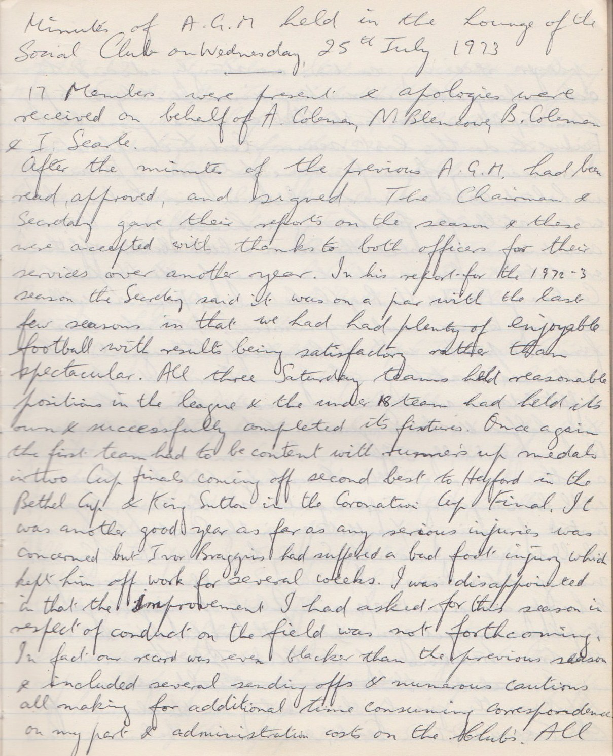

**Continued**

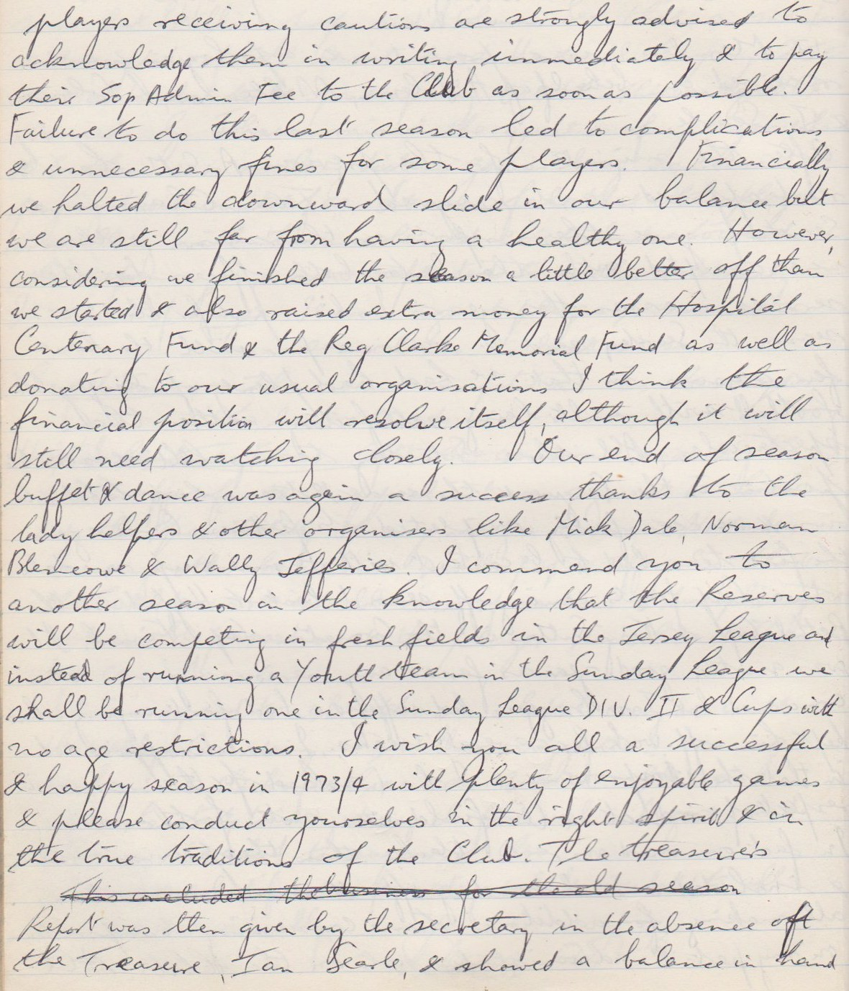

**Continued**

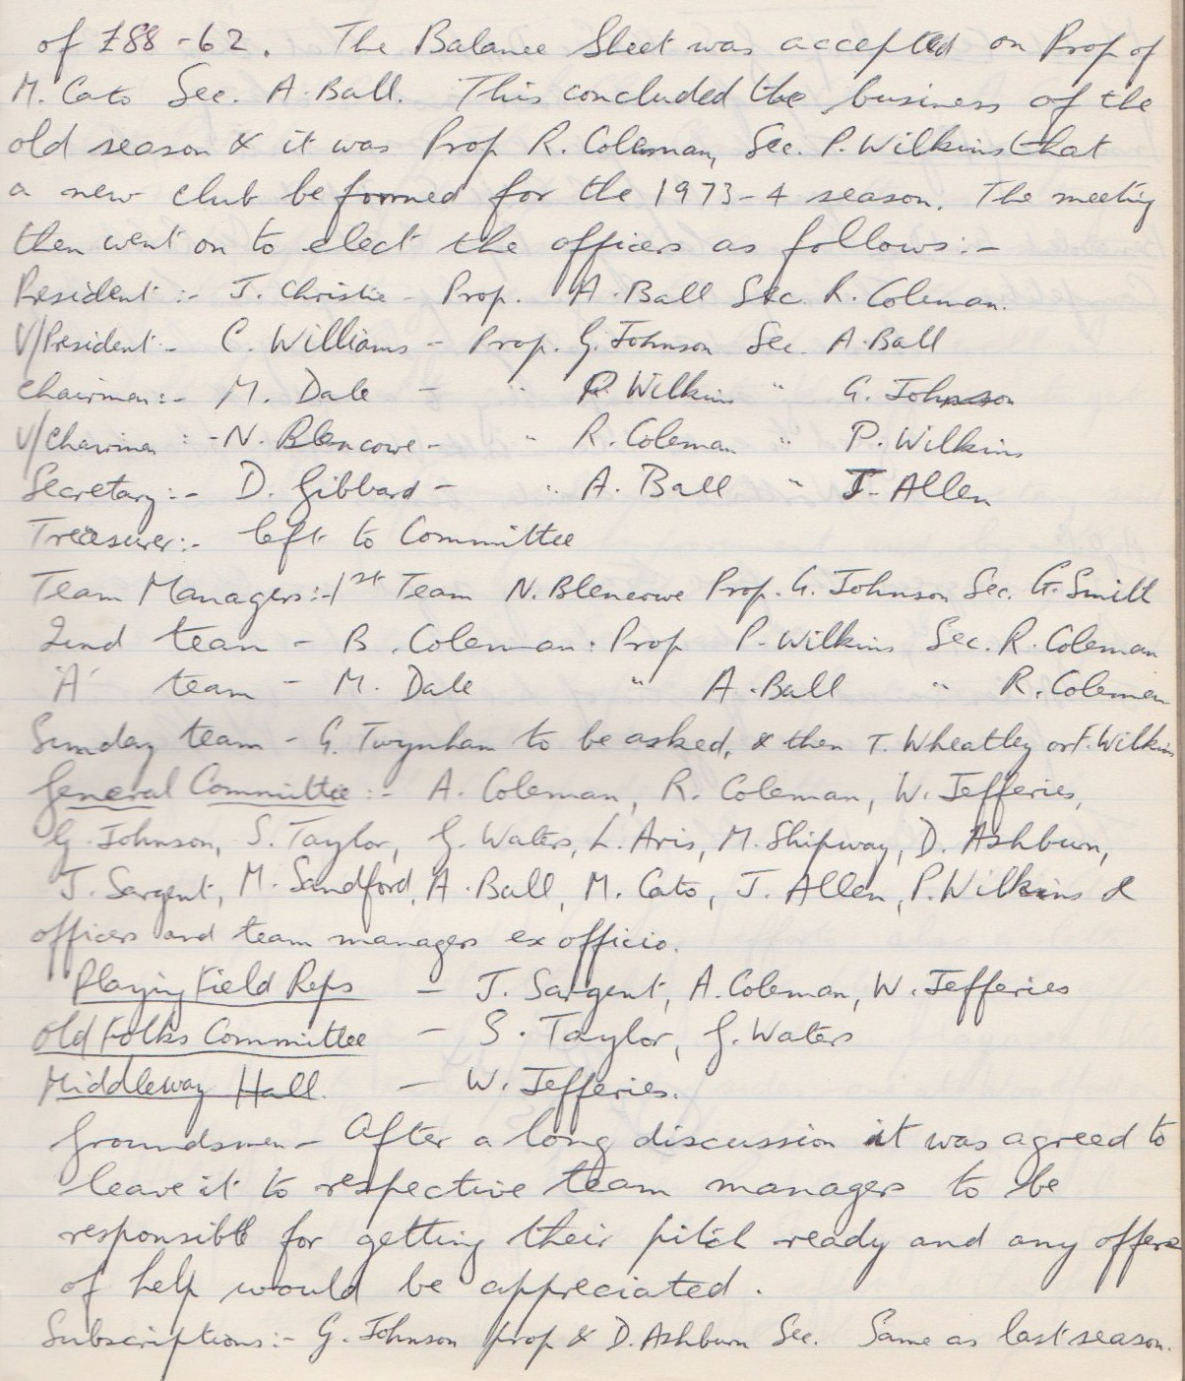

**Continued**

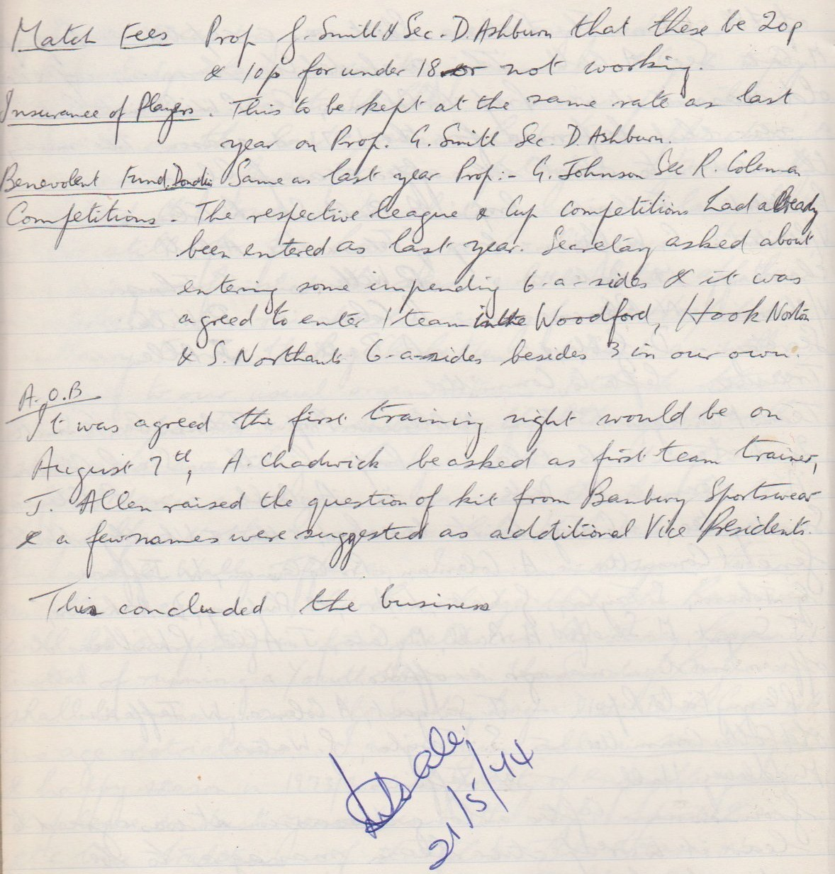

**General Committee Meeting**

**April 16th 1974**

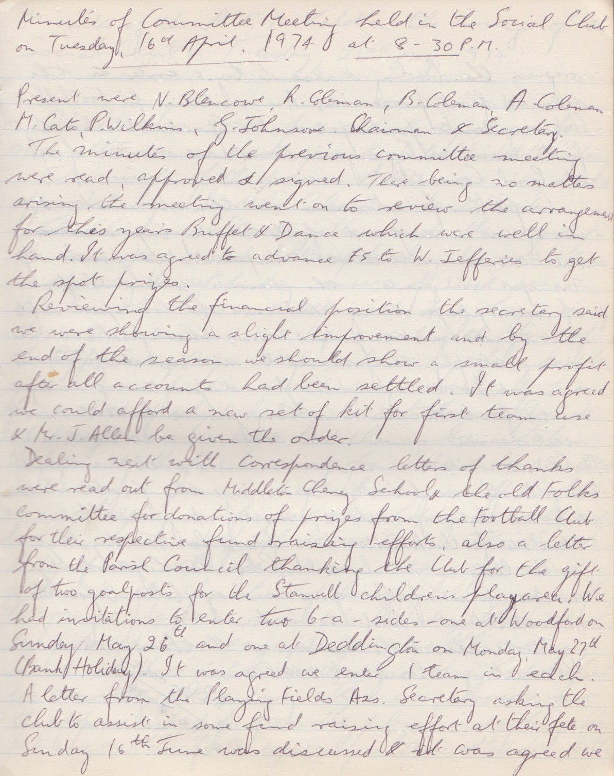

**Continued**

